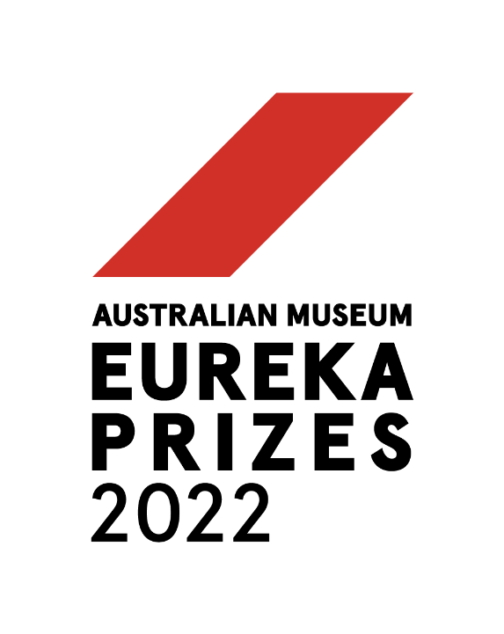

**MEDIA RELEASE**

**Embargoed until 9:30pm AEST Wednesday 31 August 2022**

**AUSTRALIA’S LEADING SCIENCE AWARDS ANNOUNCE 2022 WINNERS**

Ground-breaking research into how diets impact the environment; new tech that will revolutionise cancer diagnosis; discoveries improving the treatment of sexually transmitted infections; and scientific pioneers spearheading their industries are just some of the winners for Australia’s leading science awards, the **2022 Australian Museum Eureka Prizes**.

Winners were announced tonight at a black tie awards ceremony at the Australian Museum attended by hundreds scientists from around the country, with a total of $140,000 in cash prizes presented across 14 Australian Museum Eureka Prizes for Research and Innovation, Leadership, Science Engagement and School Science.

The Australian Museum Eureka Prizes are the nation’s leading national science awards and have been at the forefront of recognising the country’s leading scientific minds for the past 32 years. Over that time, more than $4 million dollars in prize money, and a total of 476 Eureka Prizes have been awarded.

**Australian Museum Director and CEO, Kim McKay AO**, congratulated the 2022 winners and highlighted the impact Australian scientists have on tackling global issues.

“We are facing major global challenges that require collaborative actions across governments, universities, cultural institutions and creative individuals,” McKay said

“The scientists recognised tonight show that the odds are in our favour to find solutions to those challenges. Their achievements demonstrate that we have the resources and ideas – from 3-D printing, alternative and green energy, nanotechnology, and synthetic biology – to build a world that helps sustain us for the future,” McKay added.

Established in 1990, the AM Eureka Prizes were created to celebrate the work of Australian scientists, and how their contributions are producing world-leading results that can influence the lives of many across the globe.

“From trailblazers in sustainable packaging, robotic imaging and Motor Neuron Disease research, the winners of the 2022 Australian Museum Eureka Prizes show the very deep breadth of talent we have representing Australia on the world stage,” McKay said.

**The 2022 AM Eureka Prize Winners are:**

**LEADERSHIP**

***Department of Defence Eureka Prize for Leadership in Science and Innovation***

**Professor Raina MacIntyre, UNSW**

A public health physician, epidemiologist and researcher, Professor Raina MacIntyre has taken a significant leadership role in the international response to the COVID-19 pandemic. Her contributions to infection prevention, informed by extensive research into emerging diseases, vaccines, and masks, has helped establish international public health policies and processes.

***Eureka Prize for Emerging Leader in Science***

**Professor Sumeet Walia, RMIT University**

Professor Sumeet Walia is an entrepreneurial leader whose research is being translated into products that improve lives and promote equity. His projects include artificial vision technologies, smart window coatings, UV exposure skin sensors and infection prevention platforms. A passionate advocate for diversity and inclusion in STEM, he conducts public outreach in English and Hindi.

***University of Technology Sydney Eureka Prize for Outstanding Mentor of Young Researchers***

**Professor Paul Wood AO, Monash University**

Professor Paul Wood’s dedication to developing career opportunities for young researchers led to the establishment of the Industry Mentoring and Networking in STEM (IMNIS) program. With over 1,700 alumni, IMNIS is the largest mentoring program for PhD students and early career researchers in Australia. Professor Wood continues as an active mentor for post-graduate students.

**RESEARCH & INNOVATION**

***NSW Environment and Heritage Eureka Prize for Applied Environmental Research***

**Sustainable Farms, Australian National University**

Large-scale studies conducted over two decades have enabled Sustainable Farms to identify how biodiversity responds to management changes on farms, and to share these insights with farmers. This research has also informed BirdCast, a digital tool that enables land managers to access the science and predict which birds may live in woodlands under different scenarios.

***Eureka Prize for Excellence in Interdisciplinary Scientific Research***

**Professor Manfred Lenzen, Professor David Raubenheimer, Dr Arunima Malik, Dr Mengyu Li and Navoda Liyana Pathirana, University of Sydney**

What we eat affects both individual and environmental health. Researchers from fields spanning economics, engineering and nutrition have developed advanced data modelling techniques to trace billions of supply chains, linking food producers and consumers. Their work highlights the drivers of dietary choice and is informing policy for the United Nations and other international bodies.

***Australian Infectious Diseases Research Centre Eureka Prize for Infectious Diseases Research***

**Associate Professor Eric Chow, Professor Christopher Fairley, Professor Catriona Bradshaw, Professor Jane Hocking, Professor Deborah Williamson and Professor Marcus Chen, Monash University and University of Melbourne**

Rapid rises in sexually transmitted infections (STIs) are a growing concern internationally. Discoveries made by this team have informed new treatment guidelines and prevention strategies. Their research also established the role of saliva in transmission of STIs and pioneered resistance guided therapy – tailoring antibiotics to individuals to improve cure rates.

***ANSTO Eureka Prize for Innovative Use of Technology***

**NanoMslide, La Trobe University; University of Melbourne; Garvan Institute of Medical Research; and Peter MacCallum Cancer Centre**

By applying a patented coating created with cutting-edge nanofabrication technology, the collaborators behind NanoMslide are turning the humble glass microscope slide into a diagnostic lab. Cancer cells interact with the coating and produce an instant colour variation, enabling fast, accurate, cost-effective diagnoses without the need for specialised equipment.

***Macquarie University Eureka Prize for Outstanding Early Career Researcher***

**Dr Tess Reynolds, University of Sydney**

By developing technology to better guide robotic imaging during surgery, Dr Tess Reynolds is improving the view for surgeons as well as outcomes for patients. Partnering with the world’s largest medical device company, her pioneering techniques offer clearer, more complete images for complex cardiac and spinal surgery.

***UNSW Eureka Prize for Scientific Research***

**Professor Justin Yerbury AM, University of Wollongong**

Professor Justin Yerbury leads a research program that has challenged prevailing thought about the pathology of Motor Neuron Disease (MND), a degenerative disease with no known cure. His discoveries about its underlying molecular principles, made since he was diagnosed with MND in 2016, are driving new research into the causes of cell dysfunction.

**SCIENCE ENGAGEMENT**

***Department of Industry, Science and Resources Eureka Prize for Innovation in Citizen Science***

**The Environment Recovery Project, UNSW and the German Centre for Integrative Biodiversity Research**

Studying the impact of the 2019-2020 bushfires that devastated seven million hectares of Australian bushland is beyond the scale of scientific teams alone. The Environment Recovery Project has mobilised 1,600 volunteers who have made more than 24,000 observations that help track damage and biodiversity loss while also gathering vital recovery data.

***Celestino Eureka Prize for Promoting Understanding of Science***

**Professor Veena Sahajwalla, UNSW**

Materials scientist Professor Veena Sahajwalla is the pioneering inventor of a new generation of ‘green’ materials and sustainable products. Through her rigorous research and extensive community and industry engagement, she is shifting the mindset of the nation to see unwanted materials not as waste, but as a valuable resource.

***Australian Museum Eureka Prize for Science Journalism***

**Dr Jackson Ryan, CNET**

One of 66 people on the inaugural voyage of Australia's icebreaker vessel RSV Nuyina, Dr Jackson Ryan explores Antarctica through the lens of the climate crisis. His series Journey to the Ice Kingdom offers a snapshot of life onboard a research vessel and explains how rising temperatures, tourism and loss of biodiversity threaten the southernmost continent.

Published by CNET, 1 - 5 May 2022

***Department of Industry, Science and Resources Eureka Prize for STEM Inclusion***

**Dr Kirsten Ellis, Monash University**

Scientist Dr Kirsten Ellis invented TapeBlocks as a fun way for people with a range of disabilities to learn about and create their own electronics. The colourful, easy-to-connect blocks build circuits that run lights, fans, and buzzers, allowing users to enjoy creative electronics activities and build confidence, while challenging misconceptions about who can participate in STEM.

**SCHOOL SCIENCE**

***University of Sydney Sleek Geeks Science Eureka Prize — Primary***

**Genevieve S., Bucasia State School, Qld**

In Adaptation: Now That's Change! Genevieve examines how animals fit into their environment and what they must do to survive if their habitat changes. Combining graphics and close encounters with cuddly — and not-so-cuddly — creatures, she shows how adaptations happen over time and the sort of features that develop to help animals thrive.

***University of Sydney Sleek Geeks Science Eureka Prize — Secondary***

**Iestyn R., St John's Anglican College, Forest Lake, Qld**

Brain scanning technology shows that the human brain can adapt throughout our lives. In his film Neuroplasticity - You Can Change Your Brain, Iestyn uses colourful graphics to explain how neurons connect via synapses. Through everyday examples, he shows that when connections become crowded with data, learning prompts an editing process that makes space for new information.

**2022 Australian Museum Research Institute Medal**

In addition to celebrating the winners of the AM Eureka Prizes, the 2022 Australian Museum Research Institute (AMRI) Medals were awarded to Dr Stephen Keable, Senior Fellow, and former Manager of the Marine Invertebrates Collections at the Australian Museum and Professor Graham Durant AM, the immediate past Director of Questacon. The AMRI Medal is presented to an individual staff member, senior fellow, team from the Australian Museum Research Institute, or supporter from another museum for outstanding science and communication of their research outcomes.

**Dr Stephen Keable** was recognised for his outstanding work in marine invertebrates. During an almost 40-year career at the AM, Dr Keable has authored or co-authored descriptions of more than 39 new species of freshwater and marine isopods. Dr Keable has also actively supported the introduction of biodiversity databases and collection management excellence, and championed PhD students and citizen scientists throughout his career.

**Professor Graham Durant AM** was recognised for his outstanding service to science and science education in Australia. Professor Durant is the recently retired Director of Questacon having served 23 years at the helm of Australia’s leading interactive science communication destination for children. He leaves behind an impressive legacy on engaging scientific exhibitions, investment in citizen science projects and action on climate change by the museum and cultural sector.

**For more information and a full list of 2022 Australian Museum Eureka Prizes winners: australian.museum/eurekaprizes**

**Interviews available with winners**

**Media pack, including winner images and video** [**HERE**](https://drive.google.com/drive/folders/1eNKw9ZlYwxsrlViGXbH-IdcHa_pwERWq?usp=sharing)

Additional images of the winners at the Award Ceremony will be added on the evening of 31 August.

#EurekaPrizes

**Twitter:** @eurekaprizes **Facebook:** @eurekaprizes

**MEDIA ENQUIRIES**

**Matt Fraser, Director of Communications**

**E:** matt@originalspin.com.au **M:** 0401 326 007

#ENDS#

### About the Australian Museum

The Australian Museum (AM) was founded in 1827 and is the nation’s first museum. It is internationally recognised as a natural science and culture institution focused on Australia and the Pacific. The AM’s mission is to ignite wonder, inspire debate and drive change. The AM’s vision is to be a leading voice for the richness of life, the Earth and culture in Australia and the Pacific. The AM commits to transforming the conversation around climate change, the environment and wildlife conservation; to being a strong advocate for First Nations cultures; and to continuing to develop world leading science, collections, exhibitions and education programs. With 22 million objects and specimens and the Australian Museum Research Institute (AMRI), the AM is not only a dynamic source of reliable scientific information on some of the most pressing environmental and social challenges facing our region, but also an important site of cultural exchange and learning.